AVILA BEACH
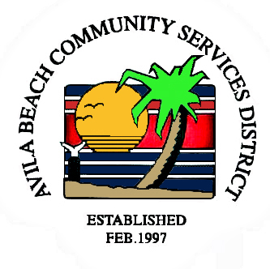
COMMUNITY SERVICES DISTRICT
Post Office Box 309, Avila Beach, CA 93424
Office and Meeting Room - 100 San Luis Street, Avila Beach
Telephone (805) 595-2664 FAX (805) 595-7623
E-mail: avilacsd@gmail.com

THE AVILA BEACH CSD REGULAR BOARD
MEETING IS CANCELED for 3/11/25.

OUR NEXT “SPECIAL” MEETING
WILL BE HELD

TUESDAY, MARCH 18th, 2025

at 1:00 PM in the DISTRICT OFFICE.

